JOB SHEET 1

STATIC ROUTING RECURSIVE NEXT HOP

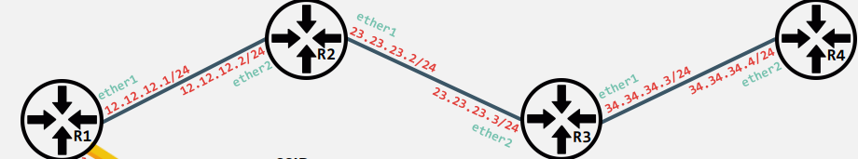

**Topologi Jaringan**

* **R1**:
  + ether1: 12.12.12.1/24
  + ether2: 23.23.23.2/24
* **R2**:
  + ether1: 12.12.12.2/24
  + ether2: 23.23.23.3/24
* **R3**:
  + ether1: 23.23.23.3/24
  + ether2: 34.34.34.3/24
* **R4**:
  + ether1: 34.34.34.3/24
  + ether2: 34.34.34.4/24

**Langkah-langkah Konfigurasi**

**1. Konfigurasi IP Address pada Semua Router**

**Router R1:**

/ip address add address=12.12.12.1/24 interface=ether1

/ip address add address=23.23.23.2/24 interface=ether2

Router R2:

/ip address add address=12.12.12.2/24 interface=ether1

/ip address add address=23.23.23.3/24 interface=ether2

Router R3:

/ip address add address=23.23.23.3/24 interface=ether1

/ip address add address=34.34.34.3/24 interface=ether2

Router R4:

/ip address add address=34.34.34.4/24 interface=ether1

2. Konfigurasi Static Routing pada Semua Router

Router R1:

/ip route add dst-address=34.34.34.0/24 gateway=23.23.23.3

/ip route add dst-address=23.23.23.3/32 gateway=12.12.12.2

Router R2:

/ip route add dst-address=34.34.34.0/24 gateway=23.23.23.3

Router R3:

/ip route add dst-address=12.12.12.0/24 gateway=23.23.23.2

/ip route add dst-address=34.34.34.4/32 gateway=34.34.34.3

Router R4:

/ip route add dst-address=12.12.12.0/24 gateway=34.34.34.3

/ip route add dst-address=23.23.23.0/24 gateway=34.34.34.3